Overall

Elbow method

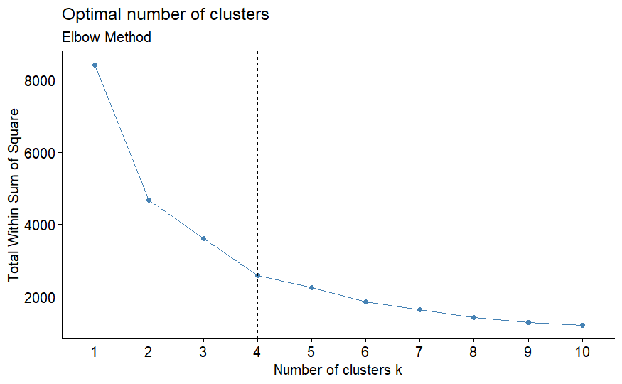

ASW

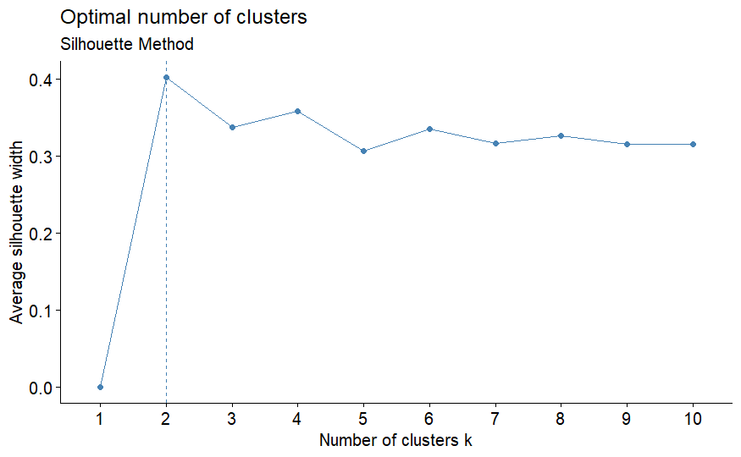

Number of clusters: 2 Average Silhouette Width: 0.4026382

Number of clusters: 3 Average Silhouette Width: 0.3369935

Number of clusters: 4 Average Silhouette Width: 0.3585108

Number of clusters: 5 Average Silhouette Width: 0.3407689

Number of clusters: 6 Average Silhouette Width: 0.3337881

Number of clusters: 7 Average Silhouette Width: 0.3427176

Number of clusters: 8 Average Silhouette Width: 0.3375038

Number of clusters: 9 Average Silhouette Width: 0.3305114

Number of clusters: 10 Average Silhouette Width: 0.3258095

Young age group

Elbow method

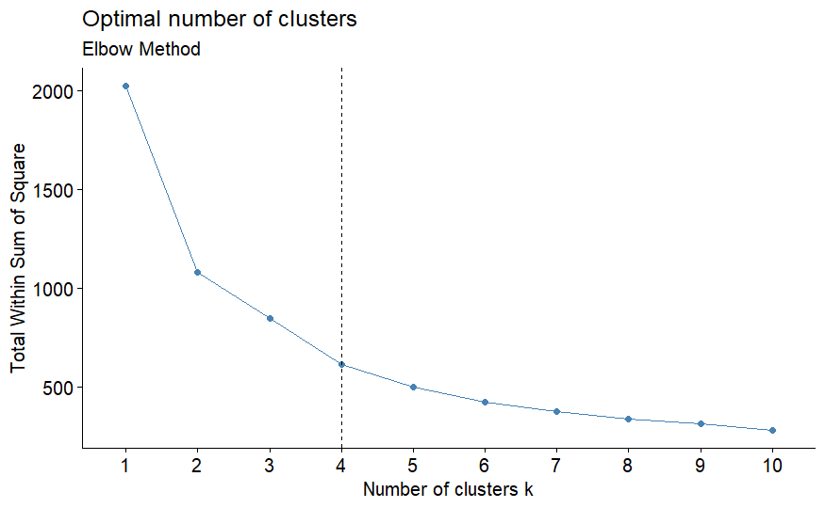

ASW

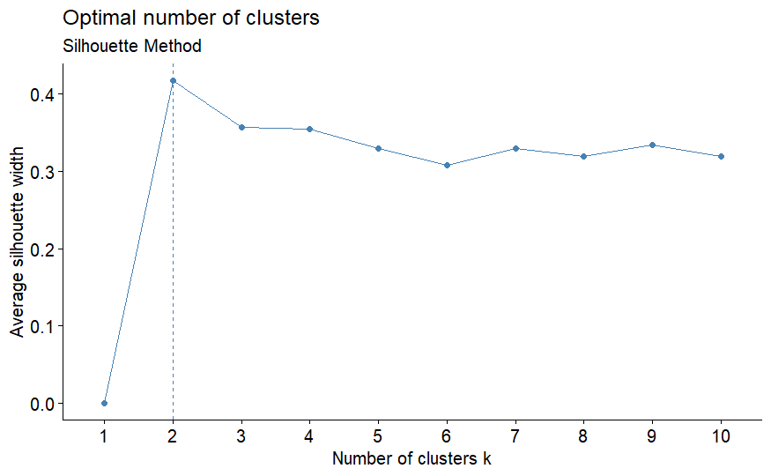

Number of clusters: 2 Average Silhouette Width: 0.4173672

Number of clusters: 3 Average Silhouette Width: 0.3255748

Number of clusters: 4 Average Silhouette Width: 0.3568778

Number of clusters: 5 Average Silhouette Width: 0.34446

Number of clusters: 6 Average Silhouette Width: 0.3407522

Number of clusters: 7 Average Silhouette Width: 0.3293849

Number of clusters: 8 Average Silhouette Width: 0.335222

Number of clusters: 9 Average Silhouette Width: 0.3345835

Number of clusters: 10 Average Silhouette Width: 0.3424884

Middle age group

Elbow method

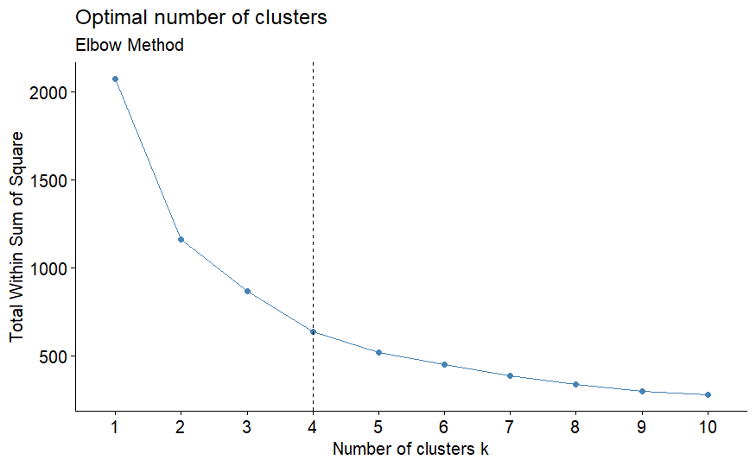

ASW

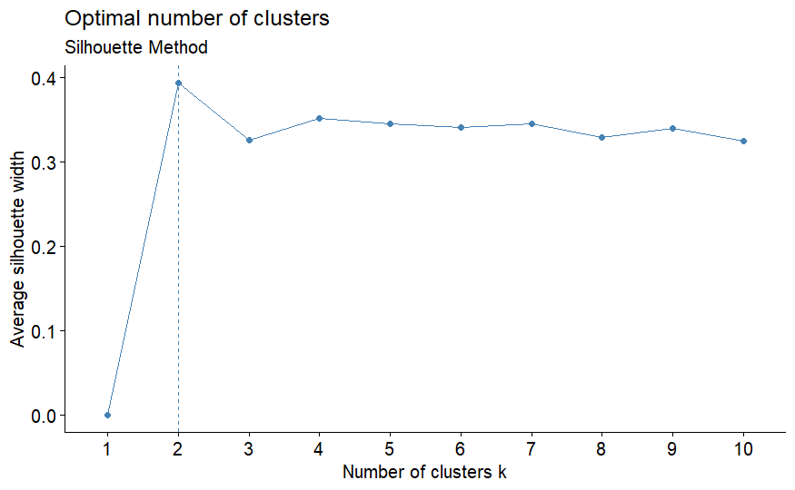

Number of clusters: 2 Average Silhouette Width: 0.3939938

Number of clusters: 3 Average Silhouette Width: 0.3257314

Number of clusters: 4 Average Silhouette Width: 0.3519981

Number of clusters: 5 Average Silhouette Width: 0.3493314

Number of clusters: 6 Average Silhouette Width: 0.3404043

Number of clusters: 7 Average Silhouette Width: 0.336136

Number of clusters: 8 Average Silhouette Width: 0.3505381

Number of clusters: 9 Average Silhouette Width: 0.3543716

Number of clusters: 10 Average Silhouette Width: 0.3394619

Old age group

Elbow method

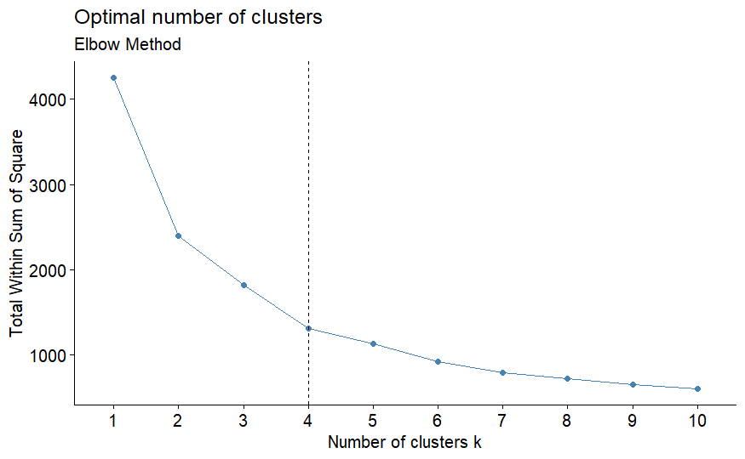

ASW

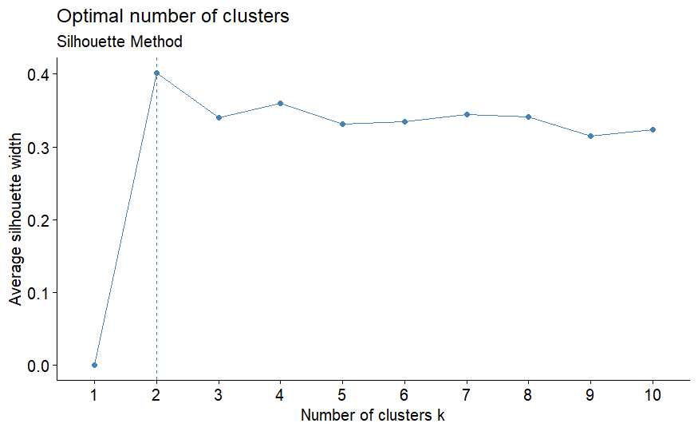

Number of clusters: 2 Average Silhouette Width: 0.4037384

Number of clusters: 3 Average Silhouette Width: 0.3382659

Number of clusters: 4 Average Silhouette Width: 0.3580387

Number of clusters: 5 Average Silhouette Width: 0.3367063

Number of clusters: 6 Average Silhouette Width: 0.3349471

Number of clusters: 7 Average Silhouette Width: 0.3454375

Number of clusters: 8 Average Silhouette Width: 0.3373322

Number of clusters: 9 Average Silhouette Width: 0.3312073

Number of clusters: 10 Average Silhouette Width: 0.3290319